**FLUME PROCESS**

1) run flume agent

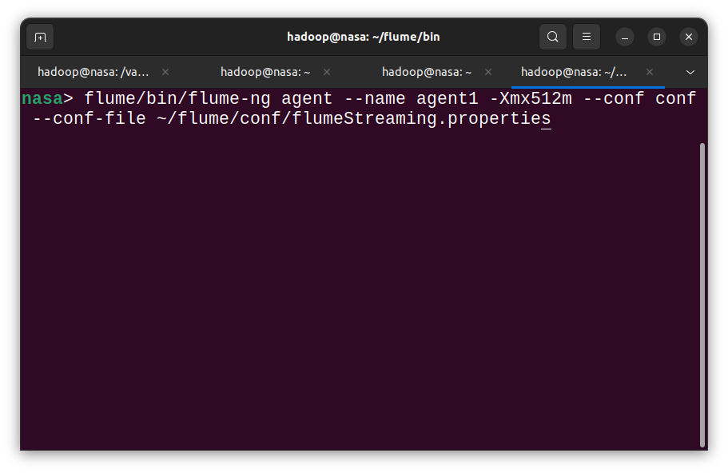

2) send data to spark streaming application

